TEST 05

READING TEST
In the Reading test, you will read a variety of texts and answer several different types of reading comprehension questions. The entire Reading test will last 75 minutes. There are three parts, and directions are given for each part. You are encouraged to answer as many questions as possible within the time allowed.
You must mark your answers on the separate answer sheet. Do not write your answers in your test book.
PART 5
Directions: A word or phrase is missing in each of the sentences below. Four answer choices are given below each sentence. Select the best answer to complete the sentence. Then mark the letter (A), (B), (C), or (D) on your answer sheet.
101. Ms. Tillinghast has received several awards ------- her innovative ideas.
(A) away

(B) for
- often
- across
- Using proper techniques to ---- --- items drastically reduces the risk of back injury.
  - select
  - lift
  - damage
  - attract
- Restaurants in Rondale must follow all - health guidelines.
  - local
  - locals
  - locally
  - localize
- Sinee's Catering is always to deliver outstanding food to your special events.
  - ready
  - skillful
  - complete
  - delicious
140
- A way to support economic growth in Ludlow City is to shop at area businesses.
  - practice
  - practicing
  - practical
  - practically
- A record number of appliance ---- --- came into the Port of Reece last month.
  - shipments
  - shipping
  - shipment
  - shipped
- At Sloat Publishing, interns are assigned to a of positions with increasing responsibility.
  - frequency
  - length
  - shortage
  - series
- The conference fee admittance to more than twenty workshops and seminars.
  - include
  - includes
  - is included
  - including
- Cabinetmaker Finley Orcheta uses the finest woodworking machines imported Denmark.
  - from
  - against
  - about
  - before
- Senior hotel manager salaries differ by company, location, and experience.
  - great
  - greater
  - greatly
  - greatest
- Pantep, Inc., works with customers to establish long-term partnerships.
  - nearly
  - closely
  - recently
  - newly
- Adalet Farm's unique method of irrigating vegetables has proved to be effective. (A) far
  - correctly
  - highly
  - much
- Customers who submit payments ------March 10 will be charged a late fee.
  - after
  - behind
  - quite
  - almost
- The poll shows how often company executives make financial decisions that are by employee opinions.
  - acted
  - trained
  - reminded
  - influenced
- Prices at Taylor City Books are lower than at other online bookstores.
  - more significant
  - significant
  - significance
  - significantly
- The of this workshop is to equip business leaders with the tools to make prudent financial decisions. (A) guide
(B) experience

(C) aim
(D) solution
- A marketing campaign was designed to target ------- of the three demographics we identified. (A) which
  - other
  - either
  - each
- ------- food critics recommend ZJ's Bistro as the best restaurant in the area, most local residents prefer Dree's Café.
  - Whenever
  - Although

(C) So that
(D) Among
- Green Grocer customers should request assistance from staff instead of removing products from the top shelves -------.
    - themselves
    - their own
    - them
    - their
- Skovent Products' sales revenue showed a improvement at the end of last quarter.
  - respective

  - crowded
  - marked
  - diverse
5
121. Before work can begin at the construction | 126. Any furniture purchased at Marty's
site, the ------- permit applications must be | Superstore throughout February will be
processed. | delivered five business days.
(A) relevant | (A) since
(B) relevantly | (B) between
(C) relevance | (C) within
(D) relevancies | (D) above
122. During negotiations, Mr. DuPont insisted that | 127. The manager presented data on employee
price be implemented without delay. | performance with on measurable
(A) expectations | achievements.
(B) institutions | (A) emphatic
(C) sensations | (B) emphasis
(D) reductions  123. After the team meeting next week, Ms. Li | - emphasize  - emphasized
- whether the project deadline needs to | 128. Even employees who ------- were not
be changed. | familiar with the new software program
(A) to decide | have found it easy to use.
(B) deciding | (A) initially
(C) will decide | (B) annually
(D) has decided  124. - the proposal for the Southside Library | - successfully  - inadvertently
garden was incomplete and had an unclear | 129. Supervisors will not ------- approve time off
timetable, it was rejected. | for employees during peak operational
(A) Until | months.
(B) Because | (A) generalization
(C) While | (B) generalize
(D) Unless  125. As the rental agreement with the Smith | - generally  - general
Group is set soon, the available office | 130. Toronto is one of three cities being ------- as
space can be advertised. | the host for the next convention of the
(A) expired | Global Society of Accountants.
(B) to expire | (A) found
(C) will have expired | (B) categorized
(D) expiring | - known  - considered
142

PART 6
Directions: Read the texts that follow. A word, phrase, or sentence is missing in parts of each text. Four answer choices for each question are given below the text. Select the best answer to complete the text. Then mark the letter (A), (B), (C), or (D) on your answer sheet.
Questions 131-134 refer to the following announcement.
We are pleased to announce that the installation of the new manufacturing equipment in our main
plant has been completed. The new machines ------- work flow by allowing for flexibility in 131. production. With six mixing tanks of ------- sizes, we expect to be able to fill a wider range of 132. orders, from small to very large. This is an important way to ensure that Balm
133.
Manufacturing continues to be a leader in the fragrance industry.
. Jim Martel, who is organizing this effort, will contact each of you soon with details. 134.

- (A) have been improved
    - were improving
    - will improve
    - improved
- (A) varying
    - varies
    - vary
    - variation
- (A) proposal
    - contract
    - impression
    - upgrade
- (A) Supervisors completed a tour of the plant yesterday.
    - Unfortunately, the installation cost more than we had anticipated.
    - As you are aware, our industry is increasingly competitive.
    - All personnel must be trained on the new equipment by the end of the month.
5

135-138 Web page.

www.kateweicommunications.com
Marketing your business can be confusing. Newspapers and magazines are useful venues 135. for advertising. - , social media platforms have become even more critical marketing outlets. iiö.-
Kate Wei Communications utilizes both traditional outlets and the latest communication
platforms. In addition to exceptional print services, Kate Wei Communications has the 137. expertise to help you ------- your online presence. Why wait? Choose our award-winning firm to 138.
strengthen your company's image today!
135. (A) still | 138. (A) optimal
(B) nowhere | (B) optimize
(C) soon | (C) optimization
(D) evenly | (D) optimum
- (A) AS a result
  - To demonstrate
  - Otherwise
  - However
- (A) Marketing professionals give conflicting advice.
  - Traditional methods have the best impact.
  - We will develop a diverse plan for your business.
  - We have recently changed our terms of service.
Questions 139-142 refer to the following e-mail.
To: Emily Swanton <eswanton@swantonfarmfeed.com>
From: Arnold Hansen <AHansen@poltonfairgrounds.org> Subject: Polton Farm Fair
Date: June 2
This e-mail serves as a receipt for your registration confirms your participation in the 139.
Seventeenth Annual Polton County Farm Fair from July 14 to July 16. As a returning exhibitor,
Swanton Farm Feed will be offered ------- space at a discounted rate. 140.
Please be aware of a new requirement when preparing your space. This year, all booths must be
completely ready by 8 P.M. on July 13. . Tables will be provided by the organizer, as in past 141.
years.
Thank you once again for your participation in our ------- . 142.
Arnold Hansen, Assistant Coordinator
Polton County Farm Fair
139. (A) whereas | 142. (A) discovery
(B) rather than | (B) survey
(C) in case | (C) event
(D) and also | (D) vote
- (A) rent
    - rental
    - rents
    - renting
- (A) This includes the removal of trash and packing materials.
    - The number of food vendors has increased in recent years.
    - The exact schedule will be announced later.
    - The Livestock Pavilion will be located next to the south exit.
143-146 article.
Sparkle Pro Enterprises Opens American Factory
Worldwide News
MANCHESTER (10 April)—Sparkle Pro Enterprises, a leading Belgium-based of cleaning 143.
products, is expanding its territory. The company has just opened its first plant in the United States, in Indianapolis. For more than forty years, Sparkle Pro has been making and distributing household and industrial cleaners to a wide range of vendors, including retail outlets and hotel chains, throughout Europe. --174-.-
The Indianapolis facility will require the company to hire 300 additional employees the end
145.
Of this year in order for it to achieve full capacity. According to Egon Bretz, the new director of North American operations, Sparkle Pro is confident that it will be able to train a large number of
personnel quickly. Mr. Bretz expects no significant ------- in meeting these needs. 146.
143. (A) produced |  | 145. (A) by
(B) producing |  | (B) despite
(C) producer |  | (C) as
(D) produce |  | (D) except
144. (A) Water-based cleaners have become |  | 146. (A) decrease
more expensive. |  | (B) challenges
(B) The company's Web site lists all of its |  | (C) project
major vendors.  - The hotels are conveniently located in most cities.  - Other factory facilities were gradually sold. |  | (D) candidates

PART 7
Directions: In this part you will read a selection of texts, such as magazine and newspaper articles, e-mails, and instant messages. Each text or set of texts is followed by several questions. Select the best answer for each question and mark the letter (A), (B), (C), or (D) on your answer sheet.
Questions 147-148 refer to the following notice.
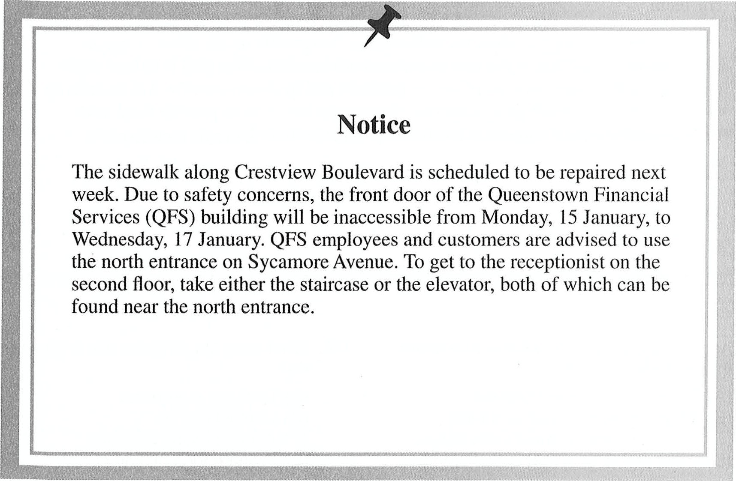
is scheduled to be repaired next door of the Queenstown Financial from Monday, 15 January, to and customers are advised to use To get to the receptionist on the the elevator, both of which can be
147. What is the purpose of the notice? 148. What is suggested about the QFS building? (A) To introduce changes to certain safety (A) Many employees work there. regulations (B) It will reopen on Thursday.
  - To announce the temporary closure of (C) The main entrance is on Crestview an entryway Boulevard.
  - To report the installation of a new (D) The renovation project will take more elevator than a week.
  - To disclose the new location of a company
149-150 e-mail.
*E-mail*
Corporate Resource Team
Junko Shigeno, Team Lead
From:
January 27
Su | ort issues
Date:
Subject:
Hi, Team,
At next week's strategy session, we will address the specific needs of our company representatives working at our new overseas retail locations. Our goal is to have each employee fully trained in marketing our products and in client retention. I'm requesting that each of you be ready to present two ideas on the best way to provide them with training and logistical support at levels comparable to their domestic counterparts.
Thanks,
Junko Shigeno
Team Lead, Integra Optics

- According to the e-mail, what is true about Integra Optics?
    - It markets corrective eyewear.
    - It has an international presence.
    - It plans to open several more stores.
    - It just produced a new line of products.
- What does Ms. Shigeno ask employees to
    - Evaluate a proposal
    - Contact clients
    - Attend training sessions
    - Prepare for a meeting
information.
Important Information 
At
Before have
If not
required
⁰
⁰
the Froehling Company, we take great pride in our high-quality, easy-to-assemble furniture, and we want you to be completely satisfied with your purchase.
beginning to assemble the product, check the parts list to make sure that all parts been included in the box.
your item is missing parts or assembly hardware, or if it has been damaged during shipping, do not return the product to the store from which you purchased it; stores do stock replacement parts. Rather, contact us directly and we will send you the item(s) free of charge. You can reach us by visiting us at www.froehlingco.com to order replacement parts online; sending us an e-mail at parts@froehlingco.com; or calling us anytime at 555-0128.

- What is the purpose of the information?
    - To inform customers where to obtain product assembly instructions
    - To notify customers how to resolve a problem involving their purchase
    - To offer a gift to loyal customers of a company
    - To help customers find nearby retail stores
- What is suggested about the Froehling Company?
    - It has customer service representatives available at all times.
    - It recommends returning damaged goods to the retailer.
    - It has a new system for keeping track of inventory.
    - It supplies a product catalog with each

order.

text-message chain.
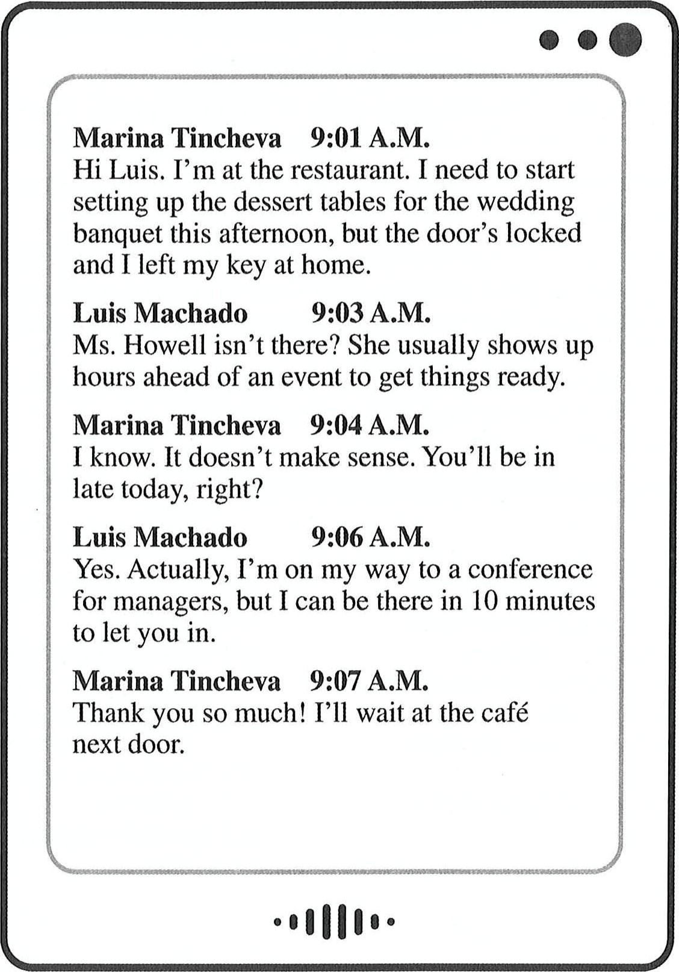

- Who most likely is Mr. Machado?
    - A café waiter
    - A dessert chef
    - A wedding florist
    - A restaurant manager
- At 9:04 A.M., what does Ms. Tincheva most likely mean when she writes, "It doesn't make sense"?
    - The bride should be there already.
    - Her coworker usually arrives early.

    - She received the wrong paperwork. (D) She does not know where her key is.
information from a brochure.
Visiting Carlin County? Don't miss these points of interest!
Avevo Botanical Garden
Open daily, 9 A.M.—6 P.M.; $8 admission
With stunning views of Gull Bay, the Avevo Botanical Garden is a beautiful place to examine and learn about the region's abundant and diverse plant life.
Rever Concert Hall
Open to the public Monday to Friday, 10 A.M.—4 P.M.
Designed by renowned architect Ang Zhao, the Rever Concert Hall has striking architecture and is well worth a visit. Guided tours are available for $2 per person.
Carlin County Museum of Art
Open daily, 1 0 A.M.—7 P.M.; $5 admission
This lovely art museum focuses on works by local artists. Special exhibits rotate monthly.
The Maritime Museum
Open Wednesday to Sunday, 9 A.M.—4 P.M.; no fee, but donations are welcome An impressive collection of historical artifacts makes the Maritime Museum a wonderful place to learn about the region's seafaring history. This museum is located on a retired ship on East Beach.

- What is the purpose of the information?
    - To provide a schedule of events
    - To give directions to notable landmarks
    - To highlight the accomplishments of local artists
    - To describe tourist destinations
- What is indicated about Carlin County Museum of Art?
    - It is closed on Mondays.
    - It was designed by a famous architect.
    - It features collections from around the world.
    - It changes some exhibits periodically.
- According to the information, what do the Avevo Botanical Garden and the Maritime Museum have in common?
    - Both charge a small admission fee.
    - Both are located near water.
    - Both display historical artifacts.
    - Both offer guided tours.
158-160 article.
Bingharn N"lan Receives Amnard
by Timur Kardos
9 October—A Bingham native received this year's Contributors Award from the Association for the Construction of Steel Bridges (ACSB), a trade organisation. Scott Moore, 66, was presented the award during yesterday's annual ACSB meeting in Norwalk.
According to an ACSB press release, the award is given every year to "an individual who has contributed significantly to the betterment of the steel industry." ACSB spokesperson Cora Schroeder said, "Mr. Moore devotes his spare time to ensuring quality in our industry. For the past decade, he has
- What is suggested about Mr. Moore?
    - He led efforts to raise standards for steel use.
    - He designed a new type of bridge. (C) He serves on a committee with Ms. Schroeder.
(D) He has received several awards from the ACSB.
- According to the article, what happened ten years ago?
(A) Mr. Moore moved to Norwalk. (B) Mr. Moore began to help the ACSB.
    - The ACSB revised its membership requirements.
    - The ACSB first presented its award. dedicated himself to helping the ACSB monitor and refine steel-production standards and practices. This year, he chaired a committee that created an improved set of standards for structural steel used in the construction of bridges."
Mr. Moore was born and raised in Bingham and received his engineering degree from Bingham University. After graduating, he worked as a construction manager during the building of Bingham's new city hall. He joined Marshall Steel 39 years ago as a building supervisor, ultimately rising to his current position of senior project engineer.
- What was Mr. Moore's first job at Marshall
Steel?
      - Senior project engineer
      - Company spokesperson
      - Construction manager
      - Building supervisor

161-164 Web page.
GDS?
Golden Day stock Photograp s
Using stock images in your materials can significantly improve your company's ability to communicate—not only with external clients but with employees as well. A well-chosen image can serve many functions, from increasing employee engagement with internal communications, to catching the attention of potential clients, to helping readers of documents better understand complex ideas.
Golden Day's images come from a unique international network of contributors, so our selection is not only large but also truly diverse. No matter the size of your organization, and no matter where you are located and with whom you do business, you will find the perfect photo to enhance your message.
Our monthly subscription plans range from $49 to $495 based on the quantity and resolution of the images you download. Once you download an image, there are no limits on its usage. Don't miss our special introductory offer: first-time subscribers qualify for consultations with our branding experts for six months at no extra cost! Our experts will help you ensure that all your client-facing materials are cohesive and make your company stand out.

161. What reason to use stock images is NOT | 163. The word "resolution" in paragraph 3, line 1,
mentioned in the advertisement? | is closest in meaning to
(A) To encourage employees to read | (A) level of detail
company newsletters | (B) statement of agreement
(B) To keep current customers interested in | (C) subject matter
a company's brand  (C) To attract new customers | (D) firmness of purpose
(D) To help clarify written information | 164. What is Golden Day offering to new customers?
162. According to the advertisement, why are | (A) Free marketing advice
Golden Day's images special? | (B) Discounts on subscription plans
(A) They are a larger size than is typically | (C) Limited-time access to additional photo
offered. | collections
(B) They are created by famous photographers. | (D) Introductions to potential new clients
    - They are used by multinational companies.
    - They are sourced from all over the world.
165-167 article.

VVe're Doing Son-nething Right

by Ariel Garman
SUSTERN (November 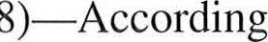 to a recent study conducted by the MidAtlantic Hotel Association, tourism at our beaches improved significantly this past summer, and the hotel industry showed greater profits this year than last. Hotel occupancy averaged 94 percent during the peak summer months.
Sustern saw the opening of the area's largest hotel, The Glaston, last spring. The new hotel was at full capacity nearly every weekend during the summer. Weekday occupancy also exceeded expectations.
The hotel's manager, Anika Bastien, said,
"Tourists were thrilled with the array of amenities offered, including 24-hour dining options, a free shuttle to nearby beaches, and free Wi-Fi. In fact, many have already reserved rooms for next summer. [2] 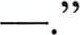
Sustern has become the most popular tourist destination in the region, with about 20 percent more beachgoers than the Delmire shore, its biggest competitor. [3] —. Experts attribute this to the growing number of outlet stores in Sustern, overall lower prices, and an abundance of new restaurants, hotels, and community events. Tourists continue to visit the area after the prime beach months, keeping hotel rooms occupied longer. — [4]
- What is the purpose of the article?
    - To announce the opening of a new hotel
    - To provide information about the local tourism industry
    - To discuss job opportunities in the hotel industry
    - To compare the quality of beaches in two locations
- What is NOT indicated about Sustern? (A) Its beach is more popular than Delmire's.
    - Its new hotel employs Ms. Bastien.
    - It hosts a wide variety of events. (D) It recently held a beach cleanup weekend.
- In which of the positions marked [1], [2], [3], and [4] does the following sentence best belong?
"This was a big increase from last summer's average of just 77 percent."
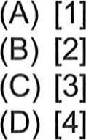

168-171 e-mail.
 | 
From:  Subject:  Date:  Attachment:  everyone,  fourth place from marketing working in  chief opportunity for sure to help keynote speech [2] I am help, please meeting. — [3]  you would return it to me Workshop ideas  Thanks,  Jessica |  | All staff
  Hello
  The take
  local
  or Our
  is
  to
  If
Jessica Perry
Conference
19 July
Workshop application
annual Australian National Sales and Marketing Conference (ANSMC) will 18 to 22 November here in Perth. Conference organizers have asked specialists to help out by giving a keynote speech, leading a workshop, the exhibition hall. —
executive officer, Martin Hughes, wants us to take advantage of this excellent
Hughes Australia Marketing to achieve visibility on a national stage. It us to expand our client base. Mr. Hughes has already agreed to give a about using survey results to create successful marketing campaigns.
designing our company's booth for the exhibition hall. If you would like come to Room C556 at 2:00 P.M. next Tuesday, 23 July, for a planning
like to lead a workshop, please complete the attached proposal form and by 26 July. — [4] —. You may present alone or with a partner. will be discussed and approved at a managers' meeting on 29 July.

- What is the purpose of the e-mail? (A) To remind staff to register for a conference
    - To apologize for missing a deadline
    - To invite staff to submit an application
    - To request responses to a marketing survey
- What is suggested about Hughes Australia Marketing?
    - It is hosting the ANSMC.
    - It is located in Perth.
    - It has been in business for four years. (D) It serves clients throughout Australia.
- According to the e-mail, why does Mr. Hughes want employees to participate in the ANSMC? (A) So they can learn new marketing strategies
    - So they can share the results of a survey
    - So they can attract new clients
    - So they can listen to his keynote speech
- In which of the positions marked [1], [2], [3], and [4] does the following sentence best belong?
"This will help me ensure that none of our workshop topics overlap."
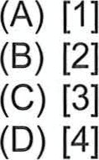

172-175 online chat discussion.
AAA

Alberto Ovando [11:15 A.M.]  When we met last week, production was nearly finished on the boxes and other packaging for Redmond's. Rani, where are we now?  Rani Verma [11:16 A.M.]  The refrigerator and dishwasher boxes were supposed to arrive at Redmond's warehouse on Wednesday, but the snowstorm really backed up our delivery schedule.  Alberto Ovando [11:17 A.M.] Have you told them this?  Stacy Pfeiffer [11:18 A.M.]  I will, but I was waiting to hear from the drivers. George, can you help?  George Kellerman [11:19 A.M.]  I spoke with them ten minutes ago. They're back on the road now, so they only lost a day. They should have everything before the end of the week.  Stacy Pfeiffer [11:21 A.M.]  OK. I'll tell them to expect delivery by Friday at the very latest.  Rani Verma [11:22 A.M.]  At least the packaging materials for the smaller appliances shipped before the storm; only the larger boxes are affected.  Alberto Ovando [11:23 A.M.]  The contract is for us to provide packaging materials for all of Redmond's products, not just the smaller ones. Let's make sure we stay on the revised schedule. | A

- For what type of business do the people most likely work?
    - A restaurant supply company
    - An appliance repair shop
    - A packaging manufacturer
    - A furniture delivery service
- What problem are the people discussing?
(A) A shipment was delayed. (B) A warehouse was closed.
    - An order was incorrect.
    - A driver did not report for work.
- What will Ms. Pfeiffer most likely do next?
    - Cancel a shipment
    - Sign the contract
    - Call a driver
    - Contact the client
- At 11:18 A.M., what does Ms. Pfeiffer most likely mean when she writes, "can you help"?
    - She thinks Mr. Kellerman should load some boxes.
    - She needs Mr. Kellerman to drive to the warehouse.
    - She wants Mn Kellerman to provide delivery information.
    - She expects Mr. Kellerman to pay the drivers.

176-180 flyer and e-mail.
PAGA's Seventeenth Annual Botanical and Horticultural Expo, July 10—13 Starkey Convention Center, Pittsburgh, Pennsylvania
The Pittsburgh Area Garden Association (PAGA) invites companies to support its garden exhibition, which last year was attended by nearly 40,000 visitors. This is a cost-effective means of reaching home gardeners and outdoor enthusiasts and enhances your firm's commercial performance.
PAGA is pleased to offer the following levels of corporate sponsorship with corresponding benefits. (For inquiries, contact Ms. Carita Aragon, PAGA's Event Coordinator, at 925-555-0142. To register, e-mail sponsors@paga.org.)
Workshop Patron—$1,250 Bag Patron-—$3,500
A representative of your company will have Your company's emblem will be on all the honor of introducing the presenter(s) of fabric tote bags, to be distributed to every a workshop, to be conducted on the second visitor.
day of the event. General Program Patron—$5,000
Charging Station Patron—$2,000 Two executives of your company will attend There will be eight mobile-device charging the PAGA Gala Banquet on the opening stations in the exhibition hall, each with a night of the expo. sponsor sign next to it.
From: caragon@ aga.org mkee@wimosol.com
Date: I Ma 15
Subject: I Thank ou
Dear Mr. Kee:
Thank you for registering Wireless Monitoring Solutions as a sponsor of the Pittsburgh Area Garden Association (PAGA) Expo. Your sponsorship not only helps to make this year's event possible, but also to generate interest in gardening.
Your contribution of $2,000 has been processed. Additionally, we are offering you sponsorship of our expo bags at no additional cost. This offer is a token of our appreciation for the long-standing support of PAGA and its programs. To finalize the promotional materials, please send us the artwork of your company's logo.
Carita Aragon, PAGA Event Coordinator

- What is the purpose of the flyer?  - To promote the benefits of participating in an event  - To present a breakdown of the costs of hosting an activity  - To report on the financial success of a fund-raising campaign  - To encourage community members to join a nature preservation project  - According to the flyer, when should a call be placed to PAGA's office? |  | - What is suggested about PAGA's event?  - It is partially funded by the Pittsburgh city government.  - It is held at a different venue every year.  - It is intended to promote enthusiasm for gardening.  - It attracts more than 40,000 visitors annually.  - What is NOT indicated about Wireless Monitoring Solutions?
 | - When a contribution cannot be processed  - When a payment has not been received  - When additional information is required  - When a change in sponsorship level must be made |  | Its name will be featured in various locations at the convention center.  - It will install wireless monitoring devices in the exhibition hall.  - It has sponsored PAGA's exhibition on various occasions.  - Its logo will be displayed on souvenir
bags.
178. What will happen on July 10 ?
  - Attendance figures from last year's expo will be released.
  - Mobile-device charging stations will be installed.
  - A workshop will be presented.
  - A formal dinner will be held.
181-185 product reviews.
 | Buy for Business Reviews Miniprojectors
HJ6 Miniprojector by Collierpro
The HJ6 is a top-of-the-line miniprojector, which is no surprise to those familiar with Collierpro. As usual, the company spared no expense in making sure this projector is easy to take almost anywhere: it is lightweight and comes with its own carrying case, which includes a remote control and a tripod. Its internal lamp is much brighter than that of other projectors its size. Due to its brightness, the HJ6 was able to project the sharpest picture of all the miniprojectors that we tested.
The major weakness of the HJ6 is its speakers. They are not nearly as loud as one would expect, given the superiority of all the other features. You can easily plug in different speakers. It is a miniprojector, however, and its small size means it is not the best choice for giving presentations in lecture halls or large conference rooms.
Overall, this is a fantastic projector for travelers, and we recommend it. This is a new model, though, and the sticker price is quite high. It may be best to hold off making a purchase right away. Projectopro will introduce the Pico PI 7 projector next month, so the HJ6's price may drop in order to remain competitive.
Buy for Business Reviews Miniprojectors
The Pocket Mini C by Excellentronics
The Pocket Mini C is a reliable projector and a good buy for those who aren't interested in spending a lot of money. Like its competitors, it is lightweight and compact. The feature we were most impressed with is its battery: it can run for up to six hours, which is much longer than the other battery-powered projectors that we tested.
There are a few downsides, as could be expected from a budget projector. The ports are in awkward locations and the menu organization is confusing, so setting up the projector is not straightforward. The audio capabilities are also limited; when the volume is turned up, the audio can sound muffled. But overall, it's a decent miniprojector for a reasonable price.
- What is suggested about Collierpro?  - It is owned by Buy for Business.  - It makes high-quality electronics.  - It is a new company.  - It offers discounts for business travelers.  - What is mentioned as a feature of the HJ6 Miniprojector?  - It is less expensive than the Pico PI 7.  - It is sold with a spare power cord.  - It has a rechargeable battery.  - It produces a very clear image. |  | - What criticism do both of the reviewed projectors receive? (A) They are too heavy.  - They are not easy to set up.  - Their sound systems do not work well.  - Their projections are not large enough.  - According to the second review, what is the best feature of the Pocket Mini C?  - Its design is attractive.  - It is easier to carry than other projectors.  - It has more ports than other projectors. (D) Its battery lasts for a long time.
183. Why should customers wait before purchasing the HJ6 Miniprojector?
- The model's features will be updated soon.
- The projector might become less expensive soon.
- Minor problems with the machine will be fixed soon.
- Another company will buy the projector's manufacturer soon.
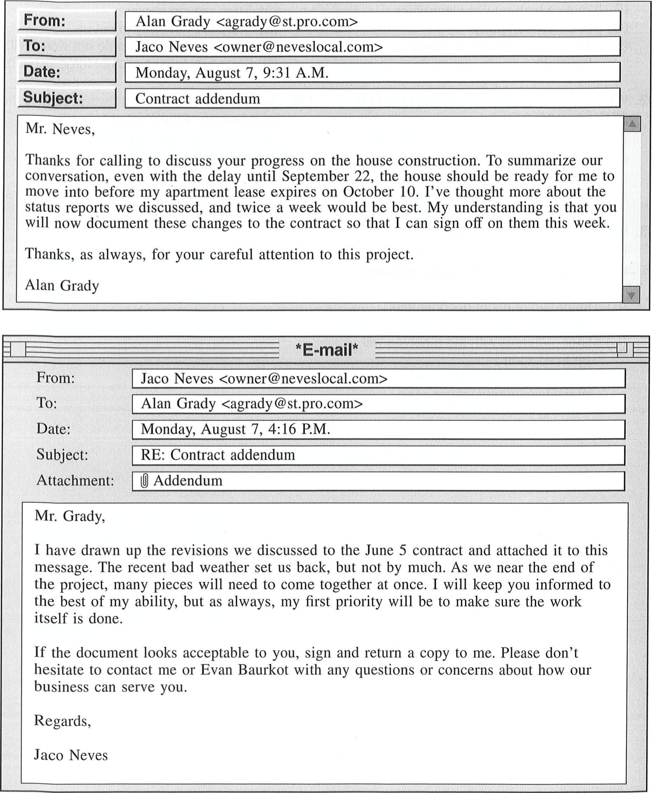
186-190
e-mails
and
form.

CONTRACT ADDENDUM
- Because of work that could not be performed due to unavoidable circumstances from July 24 to July 28, the completion date for all construction will be moved from September 17 to September 22. The Client will not be charged any additional labor costs as a result of this change. Any charges resulting from an extension of building permits will be paid by the Contractor.
- Effective immediately, the Contractor will submit a report of all work completed (including any delays incurred or anticipated) once every week, beginning on Monday, August 12.

186. Who is Mr. Grady? | 189. When was the work most likely affected by
(A) A business partner of Mr. Neves' | bad weather?
(B) A client of Mr. Neves' | (A) On June 5
(C) An assistant to Mr. Baurkot | (B) On July 24
(D) A legal advisor of Mr. Baurkot's  187. What is planned for October? | - On August 12  - On September 22
(A) A lease will be extended. | 190. What information in the contract is different
(B) A contract will be changed. | from what Mr. Grady requested?
(C) A project schedule will be revised. | (A) The frequency of the reports
(D) A house will be occupied. | - The charge for additional labor  - The date of completion  - The number of permits required
188. In the second e-mail, the phrase "drawn up" in paragraph 1, line 1, is closest in meaning to (A) raised
  - sketched
  - prepared
  - straightened
191-195 article and e-mails.
More Improvements Ahead

At its meeting on Tuesday, the Eldonbury Town Council voted to explore options for additional work to be done on town facilities. According to Charles Gruber, town clerk, the renovation of the Eldonbury Community Centre came in well under budget. The council, therefore, decided to compile a list of smaller improvement projects that could be done with the leftover funds.
Some suggested projects include adding a covered entryway to the Eldonbury Public Library, improving lighting in Westfall Park, and replacing floors in the Town Hall. According to Mr. Gruber, the council will solicit ideas from members of the public. Interested parties may voice their opinions at the council's meeting on Tuesday, 20 March, at 4:00 P.M. or send an e-mail to the council office before 31 March. After the period of public comment, the planning committee will
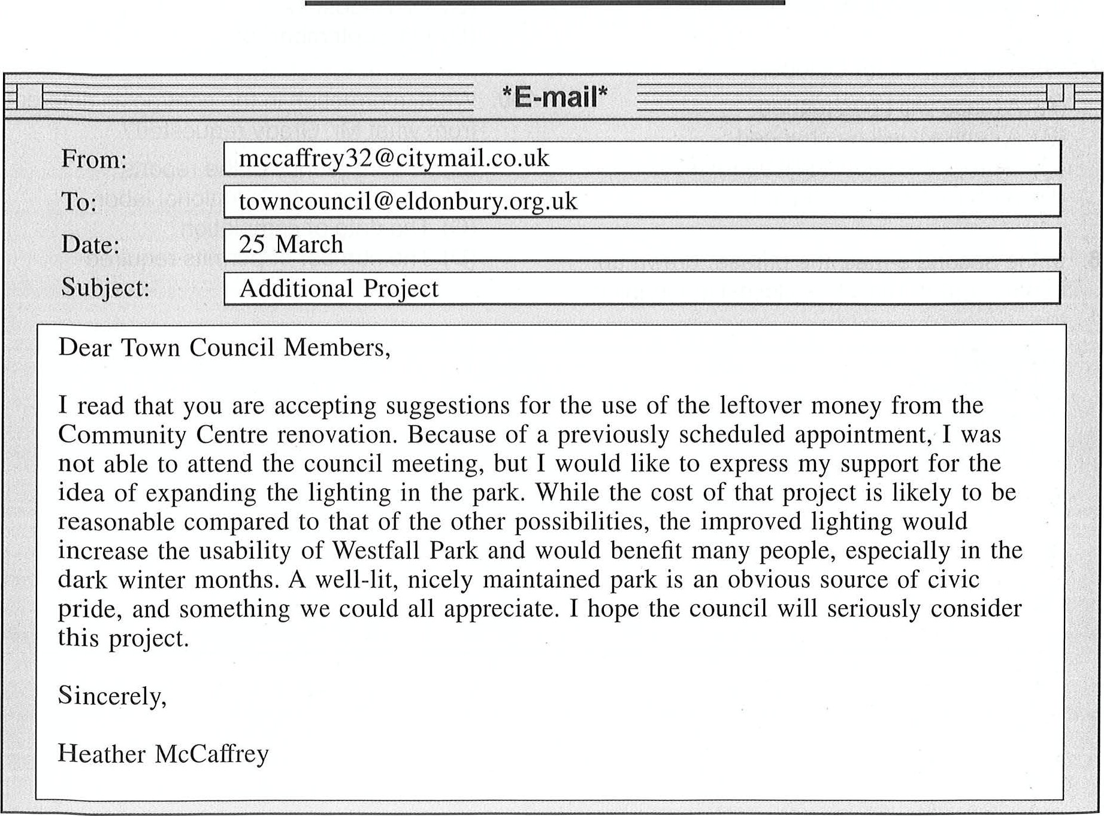
with
a
decision
expected
by
15
April.
put
forth
a
final
list
for
the
council
to
discuss,

From:  Date: | sunil.pai@hgnetworks.co.uk
  To:
  Subject:
 | towncouncil@eldonbury.org.uk
27 March
Town | ro•ects

Dear Mr. Gruber,
I was glad to hear that the latest renovation project was completed with money to spare. Although the Community Centre does sponsor activities for citizens of all ages, it is, for the most part, visited by adolescents and parents with children. Therefore, I would like to suggest that the next project focus on a place more often used by Eldonbury's older people.
The public library is a natural gathering place for older adults, and a new entryway would provide a dry, protected place for people to chat or wait for transportation. It would be a noticeable improvement, likely to be applauded by citizens who did not feel that they gained much from the improvements to the Community Centre. In April, when the votes are cast, please consider this suggestion to balance the interests of all members of the Eldonbury public.
Thank you,
Sunil Pai
- Why does the town of Eldonbury have funds available?
    - The town council has canceled a project.
    - The town has raised the tax rate.
    - A group of citizens has donated money.
    - An earlier project cost less than expected.
- In the article, the phrase "put forth" in paragraph 2, line 12, is closest in meaning to (A) grow
    - exert
    - propose
    - request
- When did Ms. McCaffrey have an appointment?
(A) On March 20
(B) On March 25
    - On March 31
    - On April 15
- What does Mr. Pai mention in his e-mail about the Eldonbury Community Centre?
    - It is located near public transportation.
    - It is used mainly by younger residents.
    - Its building previously served another purpose.
    - Its programs will run year-round.
- On what point would Ms. McCaffrey and Mr. Pai most likely agree?
    - The chosen project should be beneficial to the entire community.
    - The town should spend as little money as possible on its next project.
    - The town council should extend the deadline for public comment.
    - The patrons of the library and the park should work together to raise money.

196-200 form, e-mail, and Web page.
TAHARA AIR
Delayed Luggage Form
Dear Tahara Air Customer,
We regret that the arrival of your luggage has been delayed. Please provide the following details to help us track down and return your luggage more quickly. A Tahara Air representative will contact you by phone as soon as your luggage is located. Should your luggage remain missing for more than three days, please visit www.tahara-air.com/baggage for further instructions.
Date: 1 2 October
Name: Marzena Malewska
Local Address: Hotel Dances, Rua Jau. 1300 Lisbon. Portugal
Telephone: +44 1632 81 21 10
Flight Number: J77FG2
Delayed Luggage Information
 |  |  | Quantity | Description
 |  | Suitcase |  | small black suitcase with wheels; "Marzena Majewska" on the name tag
 |  | Backpack
 |  | C] Purse
 |  | Box |  | small cardboard box with "Marzena Majewska, Saltoni Foods" written on it
 |  | Cl Other
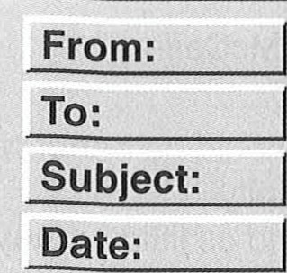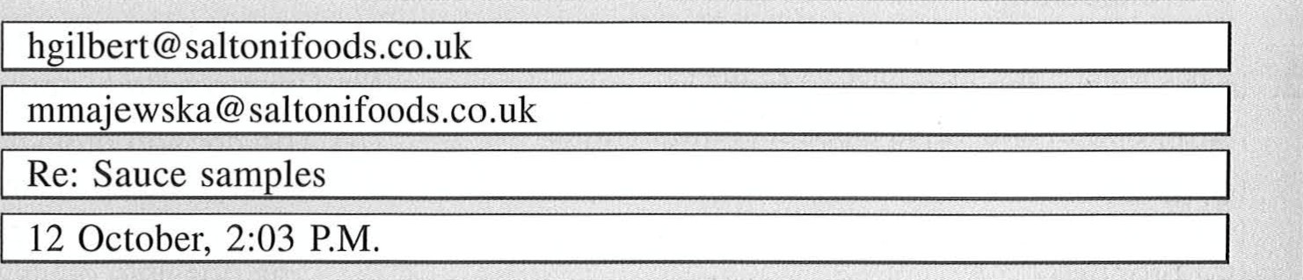

Dear Marzena,
I'm sorry to hear about your luggage. At least the airline has located your suitcase.
Since it's impossible to determine when the rest of your luggage will be found and returned, I've sent you more samples by overnight shipping. That way, you will not have to go empty-handed to tomorrow's meeting with the clients. There are five packets of each flavour as well as two small sauce jars with labels. I sent the items by BDW Shipping to your hotel. The package will be delivered by 8:30 a.m. so that you are sure to have the sauce samples and packaging to show when you speak at the meeting at 11.
Take care,
Harry Gilbert

BDW SHIPPING
The Fast and Reliable Delivery Corporation
Submit an Overnight Shipment Your shipment information:
Ship from: Saltoni Foods, 27 Aston Street, Oxford OXI IHD, UK
Ship to: Hotel Dantes, Rua Jau, 1300 Lisbon, Portugal Weight: 0.75 kg
Envelope Box C] Custom packaging
Your overnight shipment options:
€52 Ship Now
E45 Ship Now
BDW Early Morning Delivery by 8:30 A.M. tomorrow
BDW Morning Delivery by 11 A.M. tomorrow
E39 Ship Now
€31 Ship Now
BDW Afternoon Delivery by 2:00 P.M. tomorrow BDW Evening Delivery by 8:00 P.M. tomorrow
- What is indicated about Tahara Air? (A) It requires customers to include name tags on all pieces of luggage.
    - It guarantees that missing luggage will be returned in three days.
    - It will notify Ms. Majewska when her luggage is found.
    - It will reimburse Ms. Majewska for her lost luggage.
- Where did Ms. Majewska most likely pack her samples? (A) In a box
    - In a purse
    - In a suitcase
    - In a backpack
- What is implied about Mr. Gilbert?
(A) He is meeting with clients in Portugal. (B) He travels frequently for Saltoni Foods.
    - He is a Tahara Air customer service agent.
    - He wants the clients to review some products.
- According to the e-mail, what will
Ms. Majewska do tomorrow at 11 A.M.?
(A) Accept a delivery
    - Make a presentation
    - Check out of the hotel
    - Confirm her return flight
- How much was Mr. Gilbert charged for shipping? (A) E31.OO
    - E39.OO
    - E45.OO
    - E52.OO

Stop! This is the end of the test. If you finish before time is called, you may go back to Parts 5, 6, and 7 and check your work.

